Ref: CR-020 Communication Access UK
In early 2017 we asked people, including those affected by communication difficulties for their opinions We had over 3000 responses We found out that -
- people with communication difficulties don’t always get the support they need in the community
- people would like a Communication Access symbol in the UK
Businesses already use some symbols
visual
difficulties

hearing difficulties

physical difficulties

We asked people to choose an idea for a symbol to represent
communication access
These 2 ideas were the most popular Tick which idea YOU like best
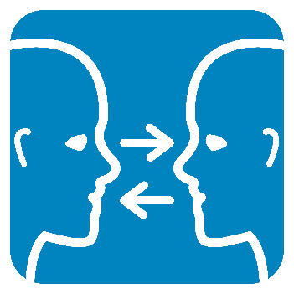 | 2 faces with ears and eyes looking towards each other  2 arrows between them, one at eye level and one at mouth level
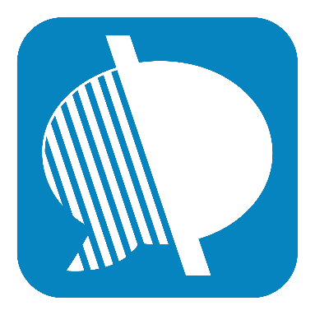 | A message or speech bubble which is shaded in half with a line through the middle

Tell us what you like and what you don’t like about these ideas
If you have any other ideas or comments please tell us

The final symbol may not look exactly like this

How should businesses help?

If an organisation displays the communication symbol it will mean the staff have been trained to help, and they are using what they learned

We asked people with communication difficulties what staff should know
These are the most popular

1 | Show me respect  Respect my communication difficulty, engage with me, and support me
2 | Give me time  Be patient, give me time to communicate, do not rush or ignore me
3. | Speak directly to me  Speak to me (rather than to the person with me) with appropriate eye contact
4. | Listen carefully  Pay attention and ask me to repeat if you do not understand
5. | Change your communication if I need it  You may need to use gesture, slow your speech and emphasize important words
6. | Use written information to support the communication  When needed, write things down in plain English, to help me remember

Are these the most important things staff should know?

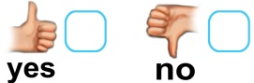

Tell us if you feel we should add something else

Please tell us about yourself
Do you have a communication difficulty?
Thank you for your help
If you are filling in this form on paper, please send it to
Communication Matters
Leeds Innovation Centre
103 Clarendon Road
Leeds LS2 9DF

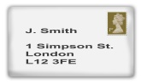

Or email to accessproject@communicationmatters.org.uk

This project is managed by a group of people from different organisations
Communication Matters
Royal College of Speech and Language Therapists (RCSLT)
The Stroke Association
The MND association
and other organisations working with people with communication difficulty.
Some people in the steering group have communication difficulties.

